Mark book Summary Instructions to get a Standard Grade Average

- Go into the mark book - Entry
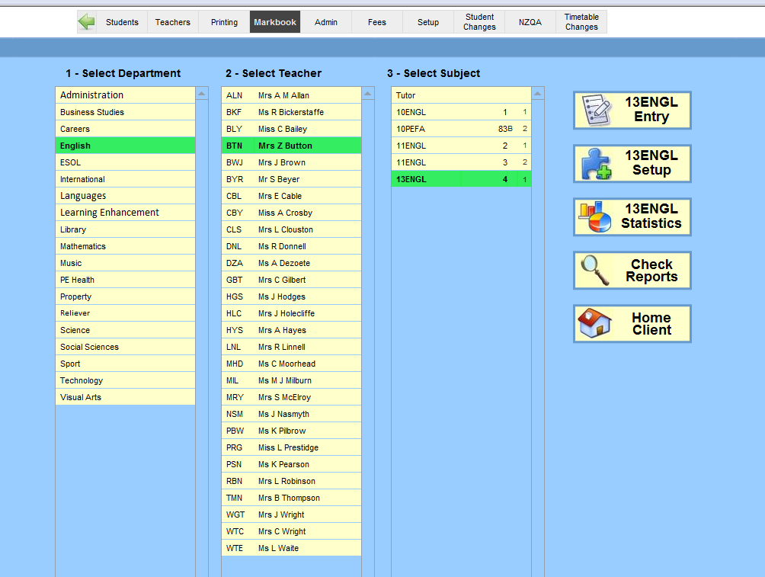
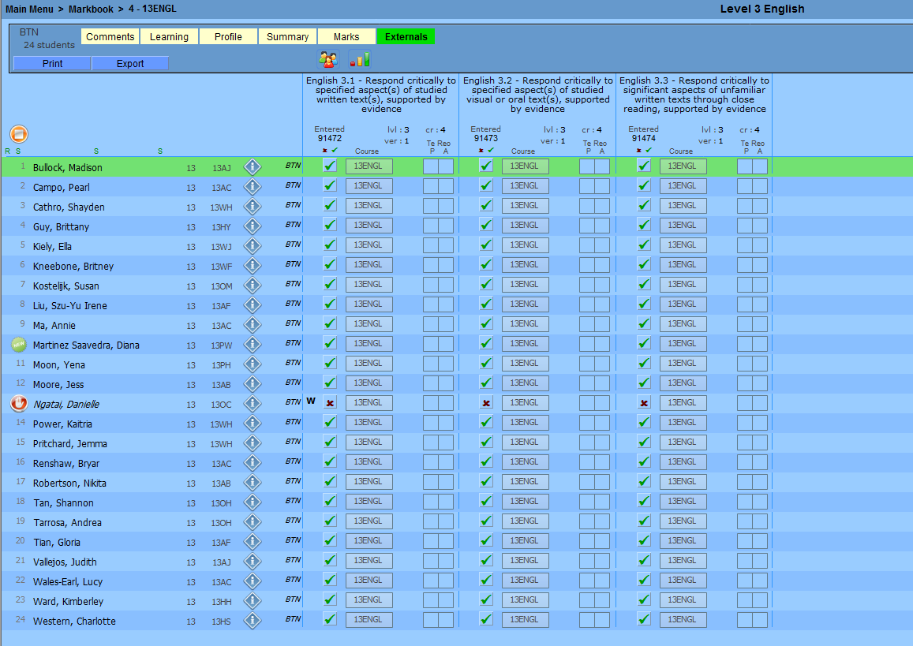
2 Once in the mark book click on Summary at the top, you can then name the mark book summary (e.g. 13ENGL or Level 3 English etc.)
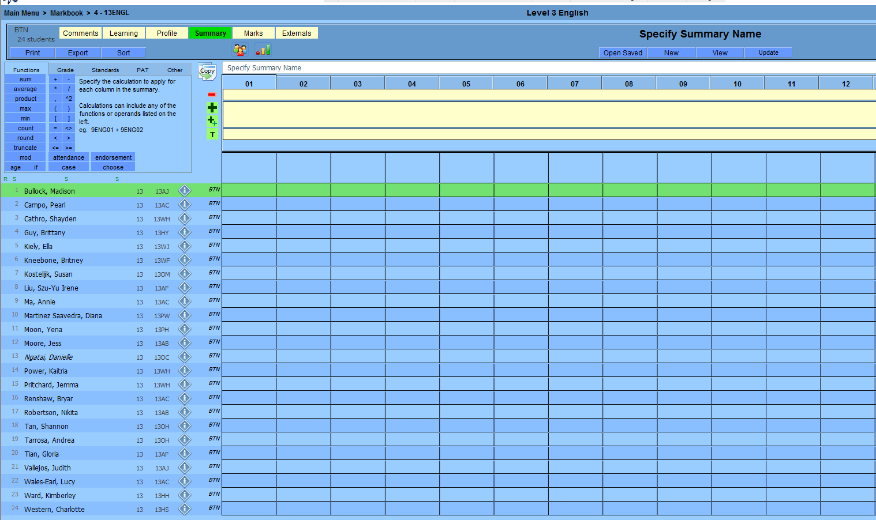
3 Then click on the three person icon at the top to Show all students in … then OK – this will bring all students from the subject into the summary
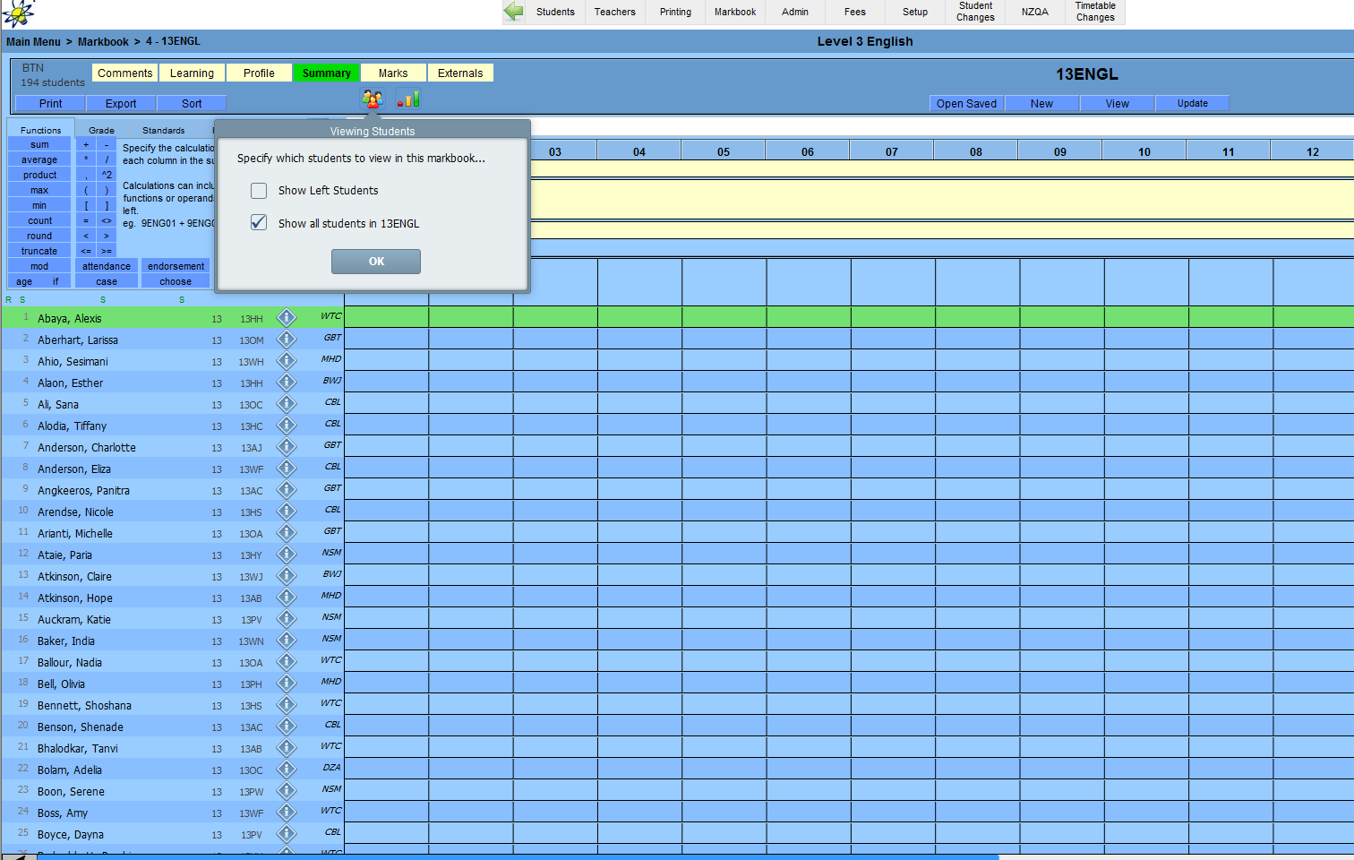

4. Make sure you are on tab 01, click on the small T – this will bring up Select which set to use, tick Set A (internals) and Set C (practice externals) - OK
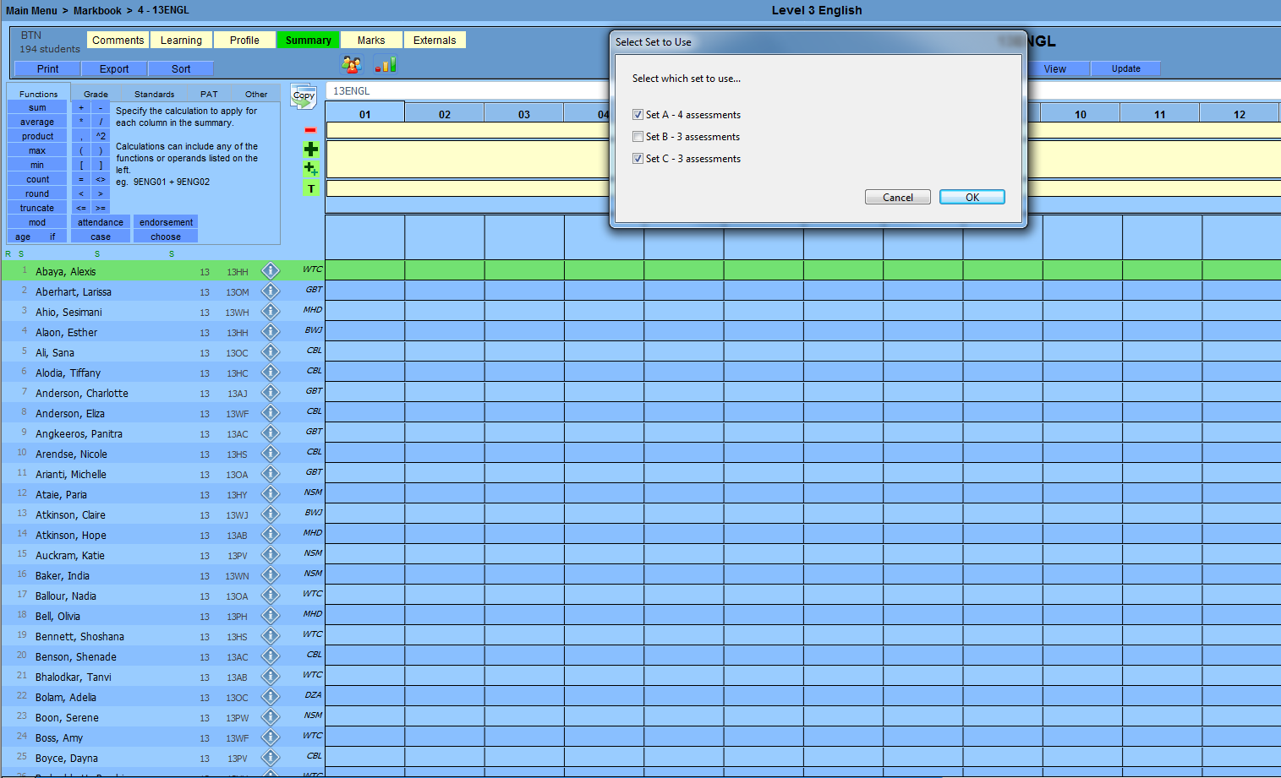
5 It will then come up with Select which Assessment Type to use… – these will all be ticked – so just select OK
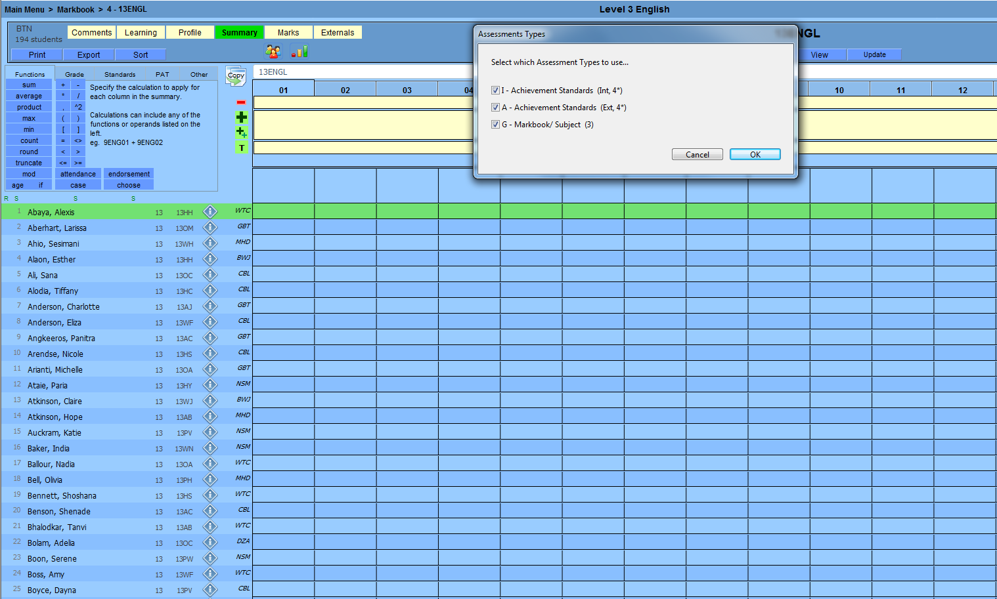

6 When you got to Select which Summary Templates to use... click on Add Assessments - OK
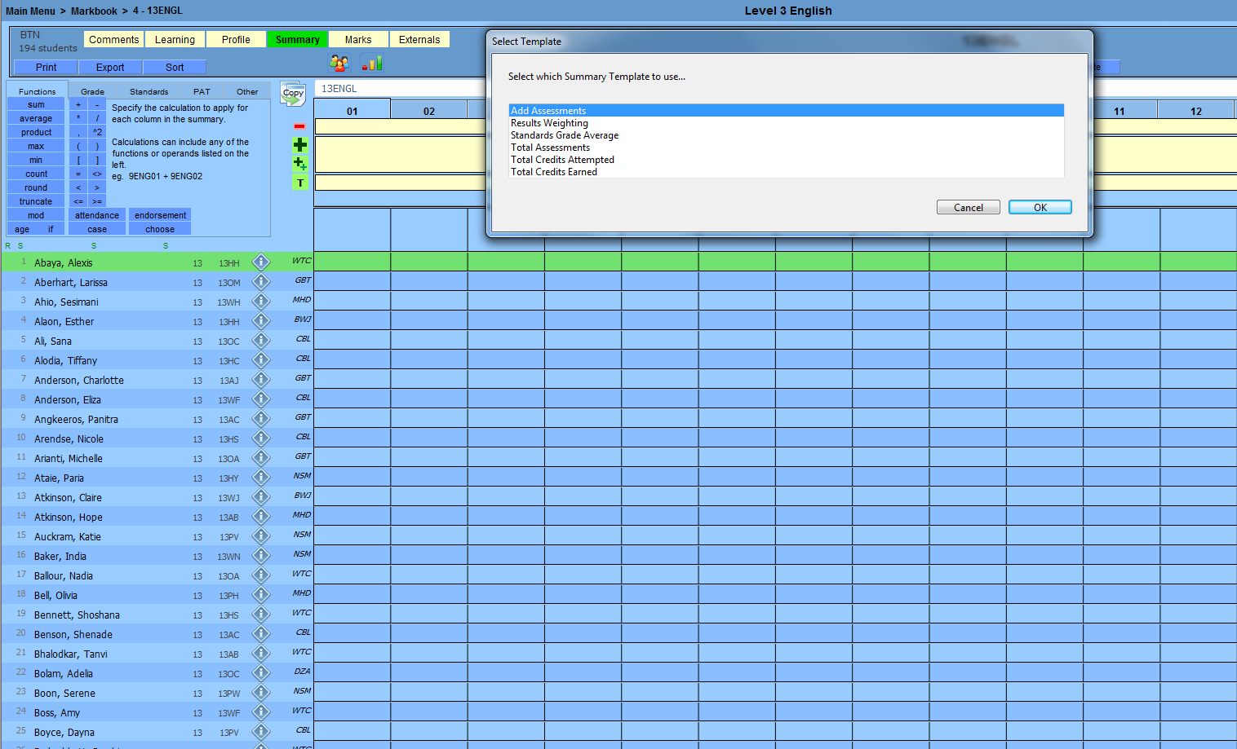
7 This will bring through all the standards from the sets that were selected earlier (sets a and c)
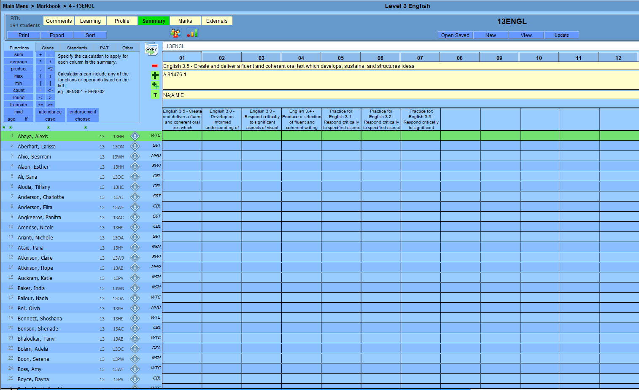

8. You will then need to follow the same process as instructions 4 to 5 – make sure you are on the last tab (in this case it is tab 08) – the two screen shots below, go through this process again
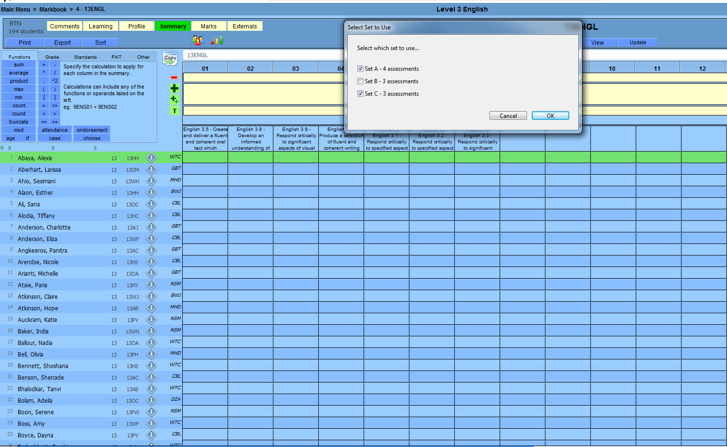
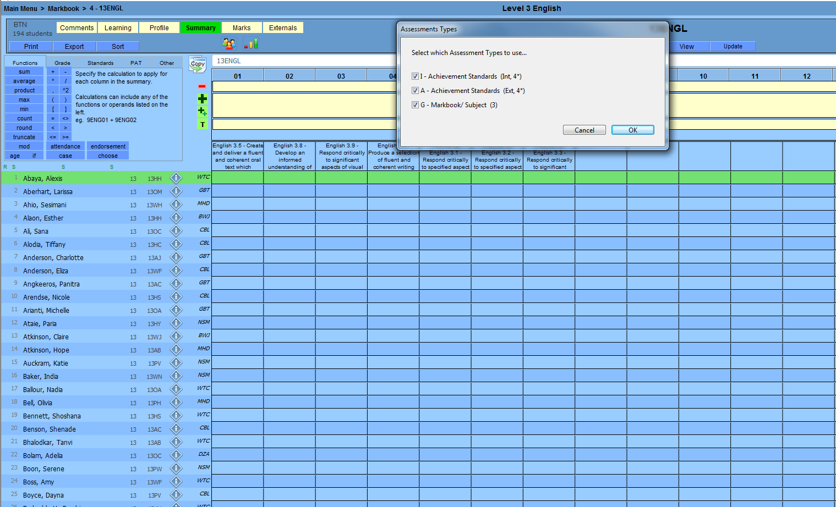

9 When you get to Select which Summary Template to use… –select Standard Grade Average - OK
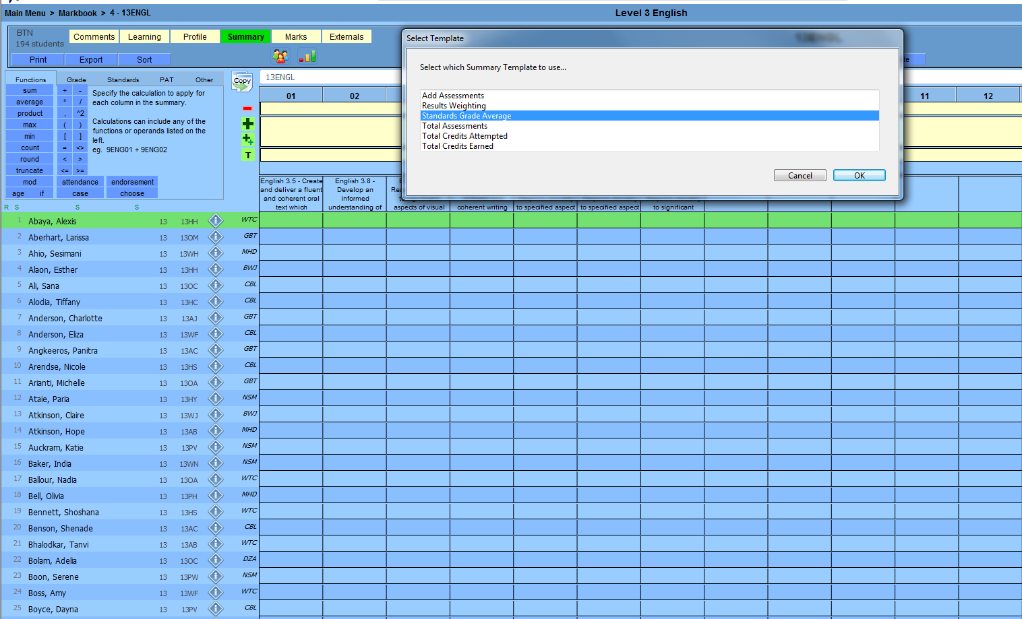
10 This brings through the title – Set Standards Grade Average
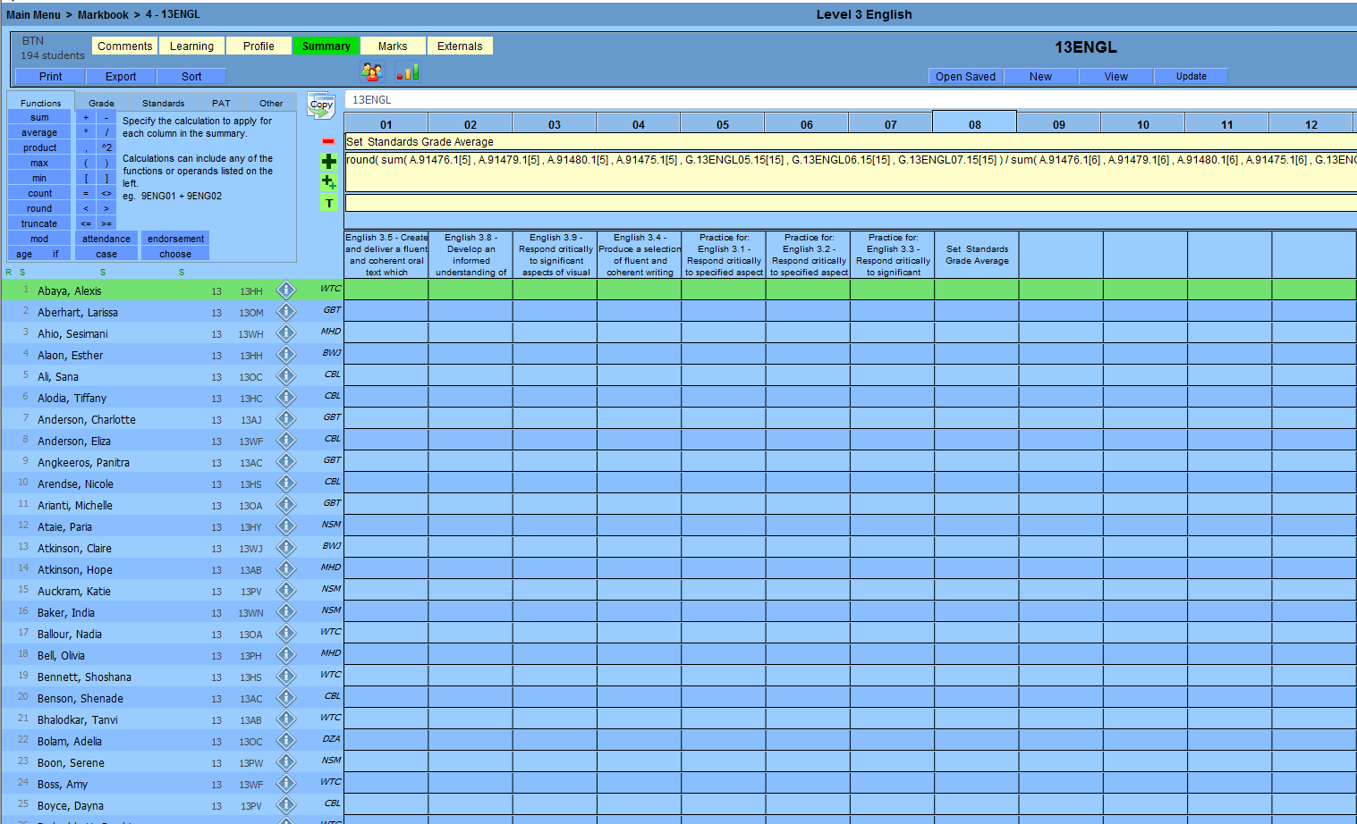

11 Now to get the grades for the standards and the grade average to show you need to click UPDATE (at the top) this will bring through all the results and standards grade average
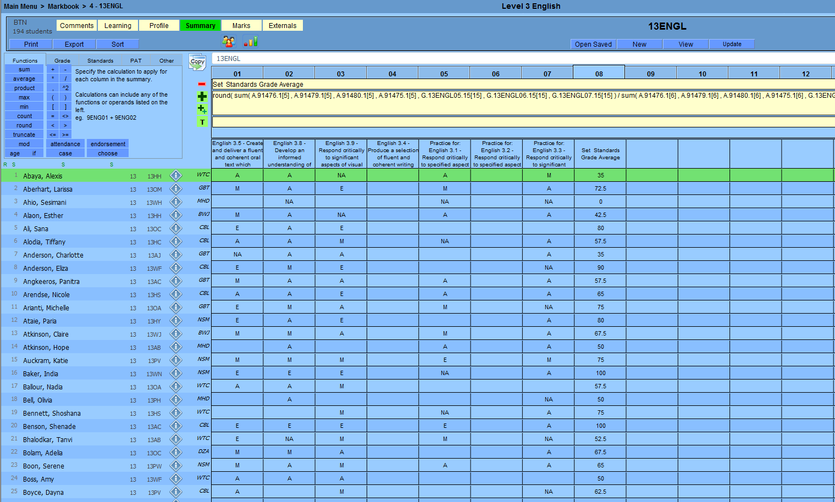
12 In the case you accidently add a column you do not want like I have in tab 09- make sure you are on the tab that you don’t want and simply click on the red minus sign (-)
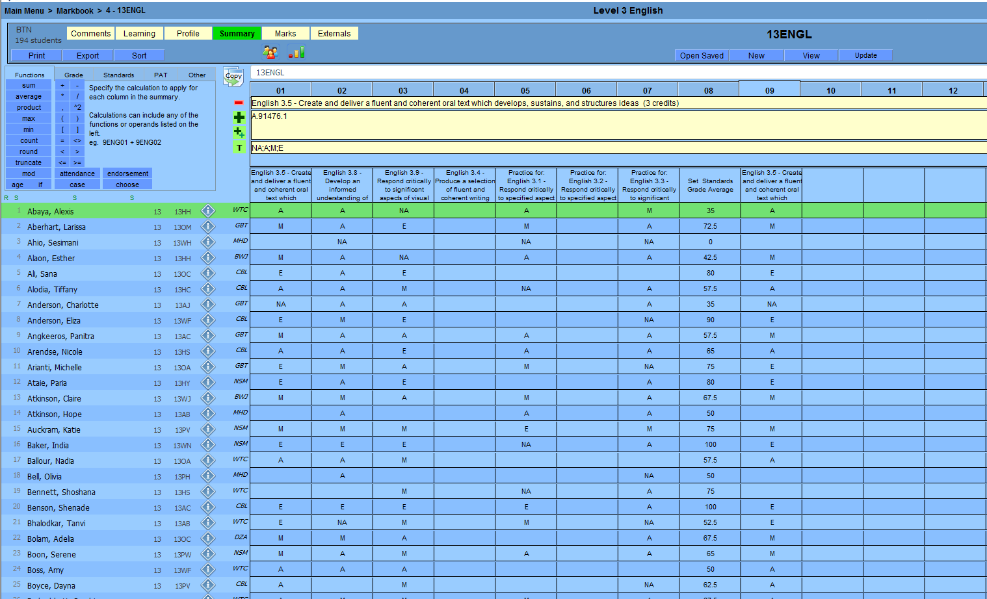

13 This will remove the title
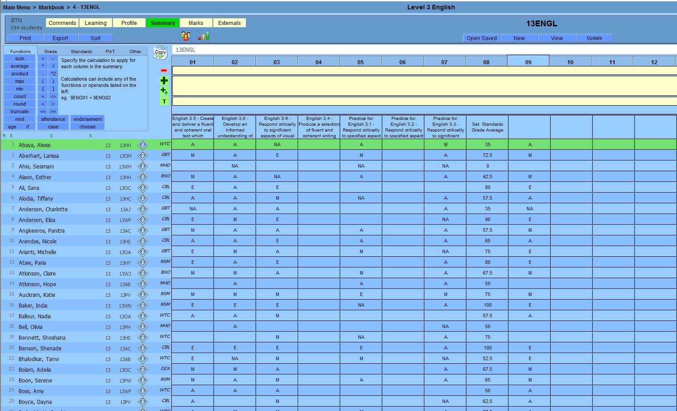
14 You will then need to click on UPDATE, to remove the grades
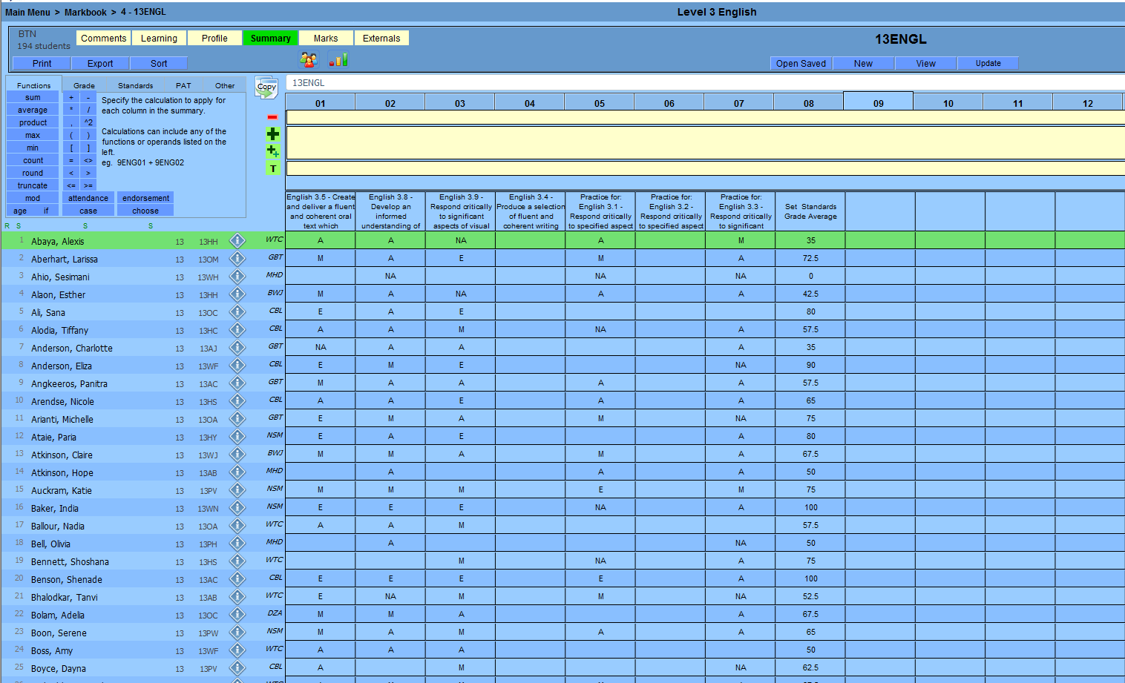

15 Once you have all the information you want in the Summary you can export it by clicking on the Export button (on the left hand side) and save the summary in the location you want
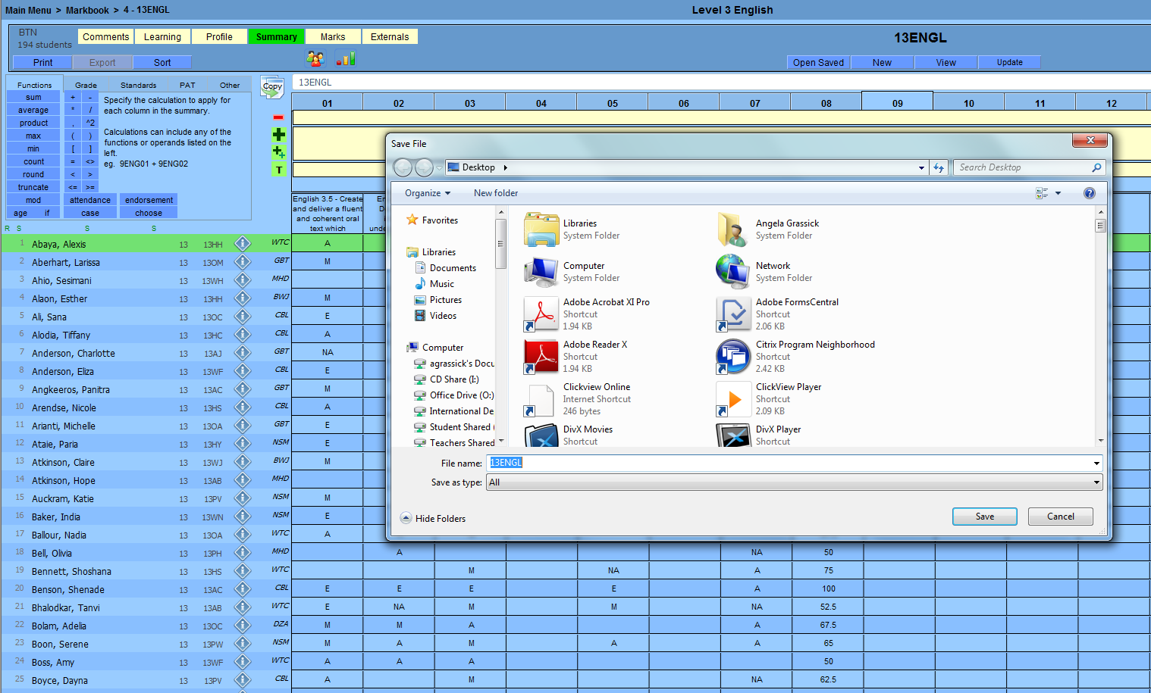

16. The excel spreadsheet will look like the below, if you like you can remove columns you don’t want like date of birth etc… (unfortunately all this extra information comes through automatically)
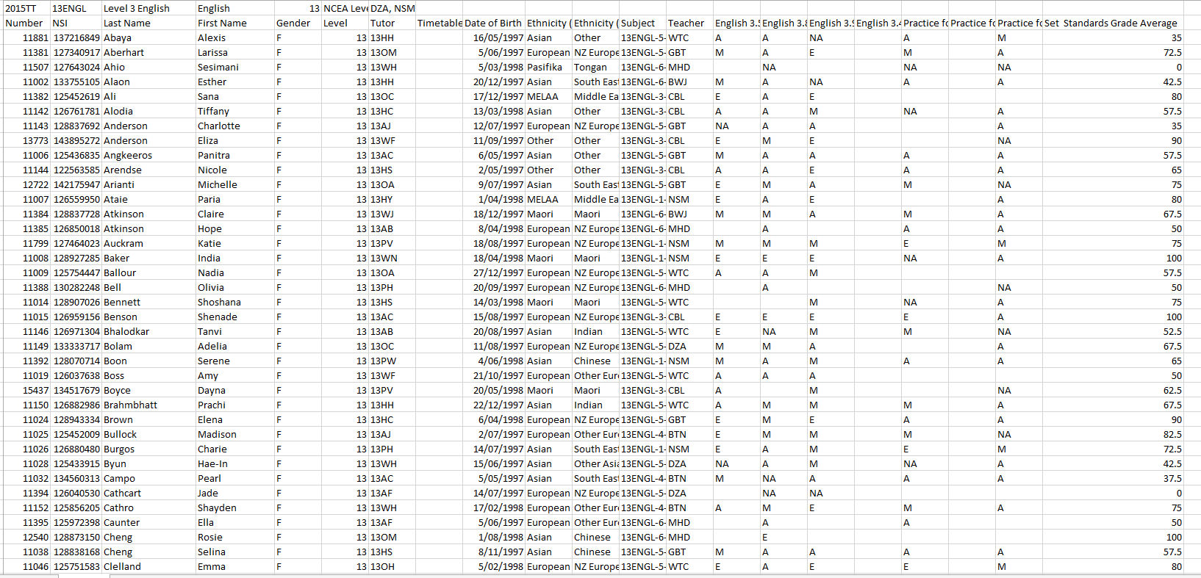

17 IMPORTANT NOTE – every time new or updated grades get entered into the mark book you must click UPDATE for them to flow through to the Summary.

